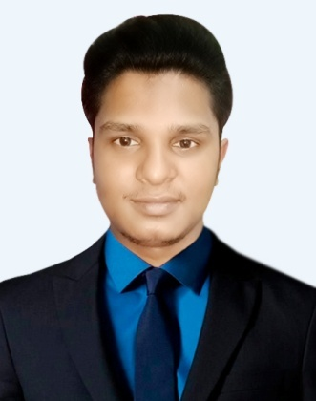**Resume OF**

**MOHAMMAD ISMILE HOSSEN**

**Mailing Address:**

**1874/D, (Ground Flour), Sabujbag, west Rampur(4216)**

**P.S- Halishahar, Dist- Chattogram.**

**Cell: 01821022414**

**E-mail: ismile.hossen@gmail.com**

**Objective:**

Build a challenging & rewarding career in an organization that provides structured career advancement within the extent of competition and dynamic crevice environment and challenging opportunities with sincerely punctuality comment, self-competency & hard work.

**Academic Qualification:**

**Masters ( M.S.S)**

Govt. City College, Chattogram.

Subject : Economics

Result : Publish not yet

University : National University

Academic Year : 2014-15

**Bachelor of Business Studies (B.B.S)**

Govt. Commerce College ,Chattogram.

Group : Business Studies

Result : 2nd Class

University : National University

Passing Year : 2013

**Higher Secondary Certificate ( H.S.C )**

Rangunia College, Chattogram.

Group : Business Studies

Result : 3.50

Passing Year : 2010

Board : Chattogram.

**Secondary School Certificate ( S.S.C )**

Narangiri Govt. High School, Kaptai

Group : Business Studies

Result : 4.06

Passing Year : 2008

Board : Chattogram.

**Language Known:**

Bengali & English fair in reading, writing, Speaking.

**Experience:**

**M/S Tasmia Chemical Ind.**

Accounts Officers (March 2015 to Oct 2016)

**BRAC**

Program Organizer( Nov 2016 to Oct 2017 )

**Rising Motors**

Manager ( Sales & Installment recovery Department )

Since May 2018 to till now

**Skill & Ability:**

* Good Communication & Interpersonal Skill.
* Good Analytic skill & Quick Learner.
* Prioritize work & meet critical deadlines.
* Sell motivated to achieve quality & performance.
* Excellent Understanding of job life cycle & ability to align company vision and goals.

**Computer Skills:**

~ Microsoft Word ~ Microsoft Excel

~ Microsoft Power Point ~ Internet Browsing

**Personal Details:**

Father’s Name : Mohammad Abdul Hamid

Mother’s Name : Nazma Akter

Permanent Address : 574, Borkhola Sandwip Para, East Kodala-4360

Rangunia,Chattogram.

Date of Birth : 06-09-1991

Nationality : Bangladeshi

Religion : Islam

Marital Status : Unmarred

Sex : Male

Height : 5’ 6’’

Weight : 65+ kg

Blood Group : B+

**Declaration;**

I am Mohammad Ismile Hossen declare with my fresh mind that above all information is fully pure.

**Signature**

**Mohammad Ismile Hossen**

Date: